lcd | device_cld

SCS 3252_006 - Big Data Management Systems & Tools
School of Continuing Studies, University of Toronto

Instructor: Katrin Shechtman
Assignment: Week 3 - Hadoop Assignment
Submitted by: Isaac Aktam
Enrollment ID: qq250757

Additional Comments:
1. Explain main differences between RDD, Dataframes and Datasets (40%) -
- RDD.
  - RDD (Resilient Distributed Dataset) is an immutable distributed collection of elements of your data, partitioned across nodes in your cluster that can be operated in parallel with a low-level API that offers transformations and actions and therefore control. We would want to use RDDs when:
    - we want low-level transformation and actions and control on our dataset;
    - our data is unstructured, such media strams or streams of text;
    - we want to manipulate our data with functional programming constructs than domain specific expressions;
    - we don’t care about imposing a schema, such as columnar format, while processing or accessing data atributes by name or column; and
    - we can forgo some optimization and perfomance benefits available with DataFrames for structured and semi-structured data.
- DataFrames/Datasets (In Spark 2.0, they merged into one API).
  - Both DataFrames and Datasets allows custom view and structure, offer high-level and domain specific operations, saves space, and executes at superior speeds.
  - DataFrames is an immutable distributed collection of data. Unlinke an RDD, data is organized into named columns, like a table in a relational database. Designing to make a large data sets processing even easier, DataFrame allows developers to impose a structure onto a distributed collection of data, allowing higher-level abstraction; it provides a domain specific language API to manipiulate our distributed data; and make Spark accessible to wider audience, beyond specialized data engineers. What’s interesting is that in Spark 2.0, DataFrame APIs will merge with Datasets APIs, unifying data processign capabilities across libraries. Because of this unification, we now have fewer concepts to learn or remebmer, and work with a single high-level and type-safe API called Dataset.
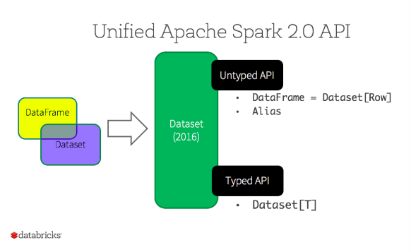
  - Datasets.
    - Starting in Spark 2.0, Dataset takes on two distinct APIs characteristics: a strongly-typed API and an untyped API, as shown in the table below. Conceptually, consider DataFrame as an alias for a collection of generic objects Dataset[ROW], where a Row is a generic untyped JVM (Java Virtual Machine). Dataset, by contrast, is a collection of strongly-typed JVM objects, dictated by a case class we define in Scala or a class in Java.
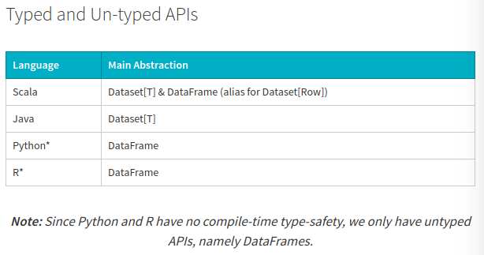
    - So, what are the benefits of Dataset APIs?
      - Static-typing and runtime type-safety. Consider static-typing and runtime safety as a spectrum, with SQL least restrictive to Dataset most restrictive. For instance, in our Spark SQL string queries, we won’t know a syntax error until runtime (which could be costly), whereas in DataFrames and Datasets one can catch errors at compile time (which saves developer-time and costs). That is, if we invoke a function in DataFrame that is not part of the API, the compiler will catch it. However, it won’t detect a non-existing column name until runtime.
At the far end of the spectrum is Dataset, most restrictive. Since Dataset APIs are all expressed as lambda functions and JVM typed objects, any mismatch of typed-parameters will be detected at compile time. Also, our analysis error can be detected at compile time too, when using Datasets, hence saving developer-time and costs.
All this translates to is a spectrum of type-safety along syntax and analysis error in our Spark code, with Datasets as most restrictive yet productive for a developer.
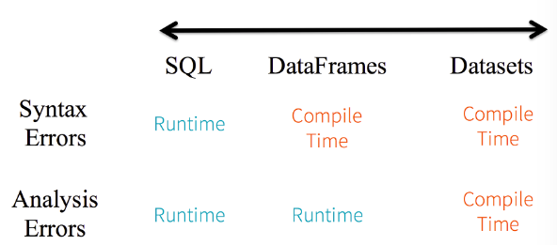
      - High-level abstraction and custome view into structured and semi-structured data. DataFrames as a collection of Datasets[Row] render a structured custom view into our semi-structured data. With Dataset as a collection of Dataset[ElementType] typed objects, one seamlessly gets both compile-time safety and custom view for strongly-type JVM objects. And the resulting strongly-typed Dataset[T] can be easily displayed or processed with high-level methods.
      - Easy-of-use of APIs with structure. Although structure may limit control in what our Spark program can do with data, it introduces rich semantics and easy set of domain specific operations that can be expressed as high-level constructs.For example, it is much simpler to perform agg, select, sum, avg, map, filter, or groupBy operations.
      - Perforamance and optimization. We cannot overlook the space efficiency and perforamnce gains in using DataFramse and Dataset APIs for the following reasons:
        - First, because DataFrame and Dataset APIs are built on top of the Spark SQL engine, it uses Catalyst to generate an optimized logical and physical query plan. Across R, Java, Scala, or Python DataFrame/Dataset APIs, all relation type queries undergo the same code optimizer, providing the space and speed efficiency. Whereas the Dataset[T] typed API is optimized for data engineering tasks, the untyped Dataset[Row] (an alias of DataFrame) is even faster and suitable for interactive analysis.
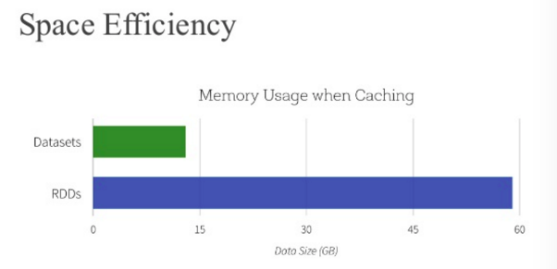
  - So, when do we use DataFrames or Datasets?
    - If we want rich semantics, high-level abstractions, and domain specific APIs, use DataFrame or Dataset.
    - If our processing demands high-level expressions, filters, maps, aggregation, averages, sum, SQL queries, solumnar access and sue of lambda functions on semi-structured data, use DataFrame or Dataset.
    - If we want higher degree of type-safety at compile time, want typed JVM objects, take advantage of Catalyst optimization, and benefit from Tungsten’s efficient code generation, use Dataset.
    - If we want a unification and simplification of APIs across Spark Librariries, use DataFrame or Dataset.
    - If one is an R user, use DataFrames.
    - If one is a Python user, use DataFrames and resort back to RDDs if one needs more control.
2. Answer following questions:
- 2.1 How many sensor pads are reported to be from Poland (10%) - As per cmd 35 and cmd 37, there are 1413 sensor pads in Poland. Used both SparkSQL and Scala.
- 2.2 How many different lcds are present in the dataset (15%) - Used both SparkSQL and Scala. As per Cmd 44 and cmd 47, the number of distinct colors is 3. As per lines 45 and 48, the number of instances of each color is as per below:
  - Green – 49699
  - Red – 49414
  - Yellow - 99051

- 2.3 Find 5 countries that have the largest number of MAC devices used (20%) - Used both SparkSQL and Scala. As per CMD 50 and CMD 52, the results are the following:
  - USA – 11836
  - CHN – 2300
  - JPN – 2002
  - KOR – 199
  - DEU - 1314

- 2.4 Introduce a new interesting analytics / algorithm you could deduct from this dataset (15%). - Please refer to the notebook.

Notebook:

https://databricks-prod-cloudfront.cloud.databricks.com/public/4027ec902e239c93eaaa8714f173bcfc/8905881237627869/3225981299721089/3266178256226325/latest.html

